**User Manual for FMixFN**

Wenwu Xu, Zhiyan Zhang*

*State Key Laboratory for Pig Genetic Improvement and Production Technology, Jiangxi Agricultural University, Nanchang, China*

[Xuwenwu248@outlook.com](mailto:Xuwenwu248@outlook.com)

[bioducklily@hotmail.com](mailto:bioducklily@hotmail.com)

Catalogue

Introduction 2

Dependencies 2

Input files 2

Training genotype file 2

Validation genotype file 3

Training Phenotype file 3

Validation Phenotype file 4

Parameter file 4

Run 4

output files 5

ebv.txt 5

Effect of marker.txt 6

Predictive accuracy.txt 6

Process of iteration.txt 6

# Introduction

FMixFN is written by Fortran90 and a stable and big data-oriented method to perform genomic selection. This genomic prediction model with four zero-mean normal distributions as the prior distribution. and the variance of the prior distribution in our model is precisely determined in advance. GEBV can be obtained accurately and quickly in combination with an iterative conditional expectation algorithm. For detailed theory, please refer to our paper: FMixFN: A fast and big data-oriented genomic selection model based on iterative conditional expectation algorithm.

Note:

Data quality control can be carried out with PLINK software.

Genotype files should not contain missing genotypes, and all individuals at the same site cannot have the same genotype. For example, a column of genotype data cannot all be zero after the genotype file is converted to 0, 1, 2 formats

# Dependencies

Fortran90

# Input files

## Training genotype file

The training Genotype file are in 0,1,2 formats, the first line of this file consists of the ID of the individual and the name for the markers. Starting with the second line, the first column is an individual number, and on the right is the marker genotype of the corresponding individual. Here is an example:

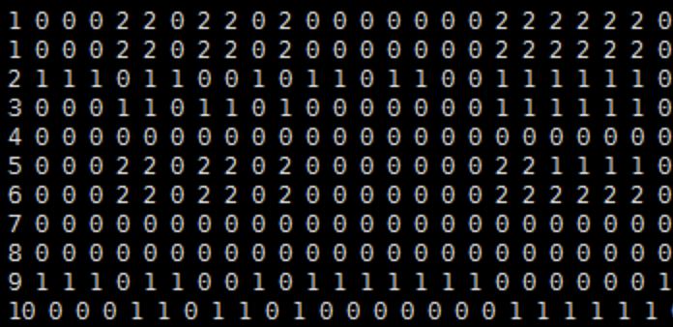

## Validation genotype file

This file is in the same format as the training genotype file, and here is an example.

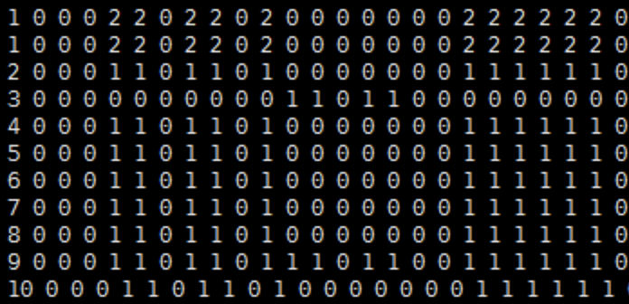

## Training Phenotype file

The first column is the individual ID, which must be the same as the ID of the training genotype file. The second and third columns are the phenotypes and the fixed effect coefficients, respectively. Here is an example.

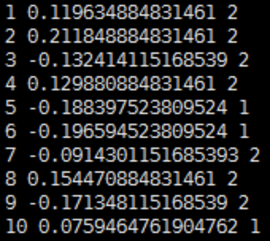

## Validation Phenotype file

This file is in the same format as the training phenotype file. Missing phenotypes are replaced by zero, and the prediction accuracy cannot be calculated without phenotypes.

Here is an example.

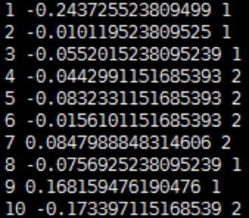

## Parameter file

There are 7 parameters in this file, which are the number of individual in the training group, the number of marker in the training group, the number of fixed effects, the proportion of the number of markers in the four categories, the heritability of the trait, and the number of individual in the validation group, the last parameter is 0 or 1, indicating whether the prediction accuracy is calculated.

# Run

with the relevant input files for FMixFN ready, it is easy for us to run the program with the following code in servers (Linux operating system).

./FMixFN

note: we compile the script file target.f90 with the gfortran compiler, which generates 64-bit version of FMixFN. If your server has a 32-bit operating system, you can compile a 32-bit FCF with the following code:

gfortran -o FMixFN32 target.f90 -m32

(note: Running the executable file FMixFN to get the final result)

the following results indicate that our program is running successfully.

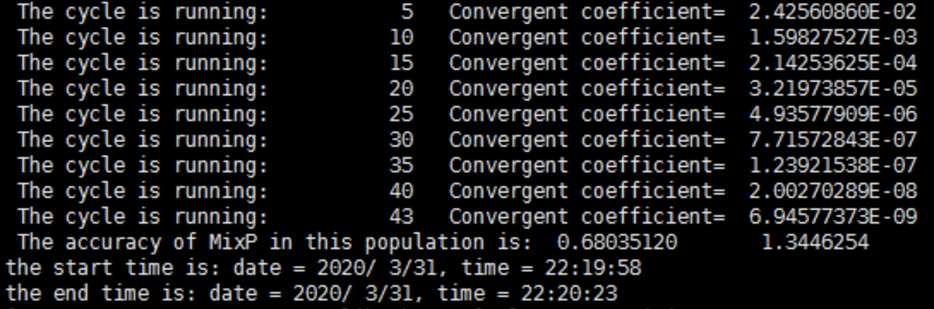

# output files

## ebv.txt

The first and second columns are the individual ID and EBV, respectively. Here is an example.

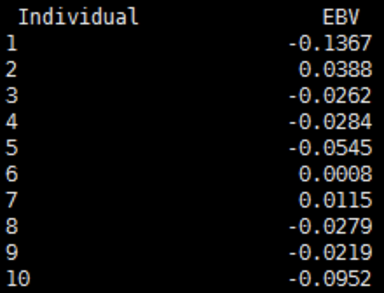

## Effect of marker.txt

The first and second columns are the marker ID and the effect of each marker, respectively. Here is an example.

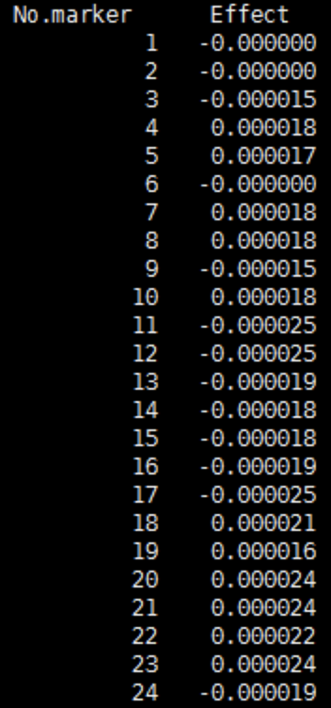

## Predictive accuracy.txt

(note: 0.68 and 1.34 represent the prediction accuracy and regression conefficients, respectively)



## Process of iteration.txt

This file record the total genetic variance and environment variance during each iteration.

